Assignment 2

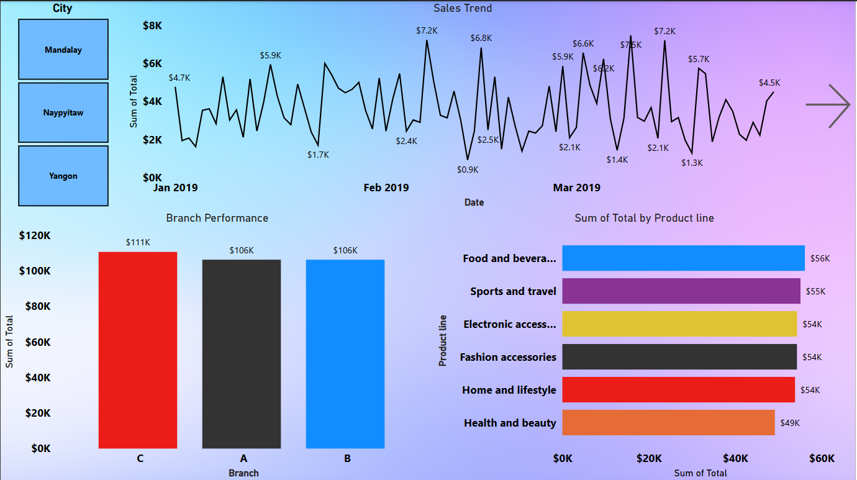

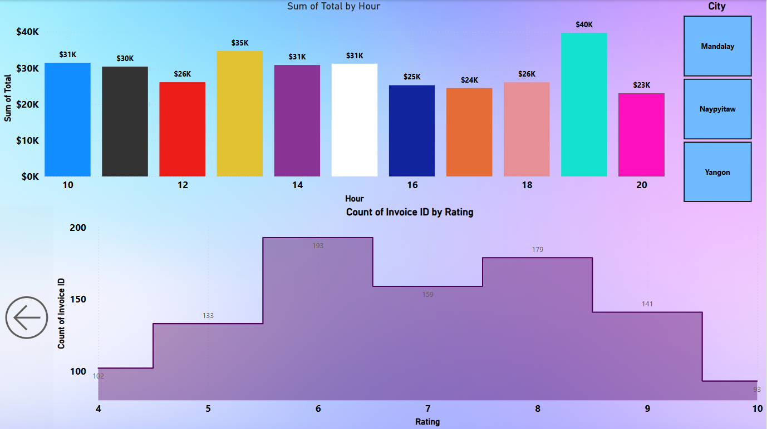

**Key Findings and Insights from the Supermarket Income Analysis Dashboard**

**1. City-Wise Sales & Payment Trends:**

* Sales are almost the same in Naypyitaw, Yangon, and Mandalay. (around ₹106K - ₹110K)
* Members and normal customers spend similarly.

**2. Payment Method Trends:**

* Most customers prefer Credit Cards (₹112.21K)
* Cashless payments are more popular than cash.

**3. Sales Trends Over Months:**

* Sales were highest in Jan-April but dropped after May.
* This could be due to seasonal demand changes.

**4. Best and Worst Selling Product Categories:**

* Food & Beverages made the most profit (₹2,674).
* Health & Beauty had the lowest income (₹2,343), meaning fewer people buy these products.

**5. Overall Income Performance:**

* Total 5510 units of Quantity is sold
* Total ₹322.97K are earned form all sales
* Total ₹15.38K is gross income earnings after product costs.
* Total 4.76% is gross margine